Ryan Kessler

Jetta Koves

Professor Franklin

Fundamentals of Game Design

9/10/2015

Blackfire

Story: The sorcerer Marius (the green player) and his two allies have infiltrated the castle of the evil sorcerer Soren (the red player) to steal the powerful Orb of Blackfire. However, when Marius took up the orb, he accidentally alerted Soren of his presence and must now race through the defenses of the castle to get to the exit with the orb before Soren steals the orb back and leaves with it. Perhaps simply to hide it, or perhaps to use it for his own nefarious purposes.

Theme: Fantasy Dungeon Crawl/Race to the End

Goal: Take the Blackfire Orb to the exit.

Loss Conditions:

1. Opponent takes orb to exit.

Set-up:

1. Turn tokens upside down and shuffle. Place one in each of the seven treasure rooms, and each player may place four tokens anywhere on the board.
2. Roll d4 to determine where the red player starts.
   1. All units begin in the starting square of each player
3. The green player starts in the marked tile at the center of the map with the orb.
4. Roll d4 to determine which exit is open.
5. Roll d4 or d6 to determine who plays red, and who plays green.
   1. Even is green, odd is red.
   2. Green always starts first.

Turn Mechanics:

1. All pieces may be moved once per turn up to their natural movement spaces (i.e. a warrior in offense can move 1, 2, or 3 spaces), or you may choose not to move some or all of them.
2. If the Orb is picked up, then all movement points for the Sorcerer are lost for that turn.
3. A token may be passed over, but if it is picked up, then all further movement points for that turn are lost for the receiving unit.
   1. The exception is with a speed token, then an additional 3 spaces may be moved.
   2. If a slow token is picked up, the loss is transferred to the following round.
   3. Tokens are used immediately with the exception of Slow and Invulnerable (which has a 2 turn duration).
4. Reviving an ally consumes any leftover movement points for that turn, the same as picking up a token would.
5. If a unit is revived and that space is being occupied by an enemy unit, that unit is automatically killed.

Mechanics:

1. Three pieces:
   1. Sorcerer/Main
      1. Moves 2 spaces naturally.
      2. Offensive only.
      3. Only unit who can hold the Orb.
      4. If not holding the orb, it can revive a friendly unit if 1 space away.
      5. If killed, respawns after 3 turns as long as friendly piece is still alive. Any opposing units within three spaces, are moved until they are four spaces from the Sorcerer.
   2. Archer
      1. Moves 2 spaces naturally.
      2. Mostly defensive.
      3. Opposing pieces cannot stop within two spaces without being killed.
         1. If two archers meet, the attacker rolls a d6 to determine who win.
            1. Attacker rolls a die. They must roll a 5 or 6 to kill the defender.
      4. May only be defeated by landing directly on top of it, or through an archer contest.
      5. If it is moved within the two space limit of an opposing piece, the opposing piece will be killed.
         1. If more than one unit is available to kill, the attacking player may choose who to attack.
   3. Warrior
      1. Two stances: Offensive and Defensive
         1. Stances may be changed only at the beginning of a turn, and only before movement has been made.
         2. Offensive
            1. Moves 3 spaces naturally.
            2. Cannot block attacks.
         3. Defensive
            1. Cannot move.
            2. Blocks all attacks, except from the Orb.
            3. No opposing piece may pass over it.
2. Orb of Blackfire
   1. Can only be held by Sorcerer.
   2. It takes a full turn to pick up the orb.
      1. If you have two or three movement points, and only use one to get to the orb, all others are lost. Even those gained by a speed token.
3. Token System
   1. 15 Tokens per game
      1. 7 tokens are placed in predetermined spaces (“Treasure rooms”), and the other eight are placed randomly by the two players.
   2. Revive Token
      1. Revive any dead unit, anywhere on the board.
   3. Recall
      1. Move archer and warrior to the Sorcerer.
   4. Invulnerable
      1. Unit is immune to 1 attack. Lasts only for 2 turns.
   5. Displace
      1. Move a single enemy unit up to 2 spaces.
         1. Can be moved through walls, but not into inaccessible areas.
         2. If an archer is displaced, it cannot immediately attack if an enemy is in range after being moved.
   6. Death
      1. Unit that collects the token is killed.
   7. Slow
      1. Unit moves 1 less space in the next turn.
   8. Speed
      1. Unit can move up to 3 more spaces immediately.
   9. Teleport
      1. Roll d6 to determine outcome.
         1. Move orb to Red start #1.
         2. Move orb to Red start #2.
         3. Move orb to Red start #3.
         4. Move orb to Red start #4
         5. Mass Recall. All units are returned to their respective Sorcerer.
         6. Unit may teleport up to 3 spaces, regardless of walls. Cannot teleport into normally inaccessible spaces.

Playtesting Notes:

Our initial playtesting very quickly revealed that our original token system had to be almost completely overhauled and expanded in order to function as it was designed. There were initially four types of tokens: teleport, speed, slow, and instant death. The teleport was expanded upon to include 6 different effects, determined by the roll of a d6. We also came up with the other tokens to give variety, and allow more potential for strategy. The invulnerability token had to be given a duration during subsequent play.

We also realized that the movement of the Sorcerers, which was originally one square, would probably need to be changed. This was confirmed, and consequently changed, in later playtesting with other players. It was during this secondary playtesting that we also came across issues with the mechanics of the archer. While initially designed to be solely defensive, a question was raised about when he moves within two spaces of another unit, and expanded to when another archer was placed within range of him via magic or movement. This was rectified by giving him some offensive capabilities on the former, and by causing a dice roll when two archers meet, giving advantage to the defender.

Another dynamic that occurred during playtesting, was the tendency to ignore the tokens and go into a Chess-like offensive. This was rectified by clarifying what the tokens did and writing a reference directly on the board to not only show what each symbol meant, but also giving information on the effects of the tokens. We also had to remove the victory condition of killing your opponent and giving the Sorcerers a 3 turn respawn time; as well as giving them the force push upon respawning to prevent camping.

Finally, the map also had to be changed during play, as certain starting conditions could very quickly favor one side. We also had to open up certain walls to prevent defense camping by a warrior, and allow for smoother gameplay.

Figure 1 Initial board layout during playtesting.

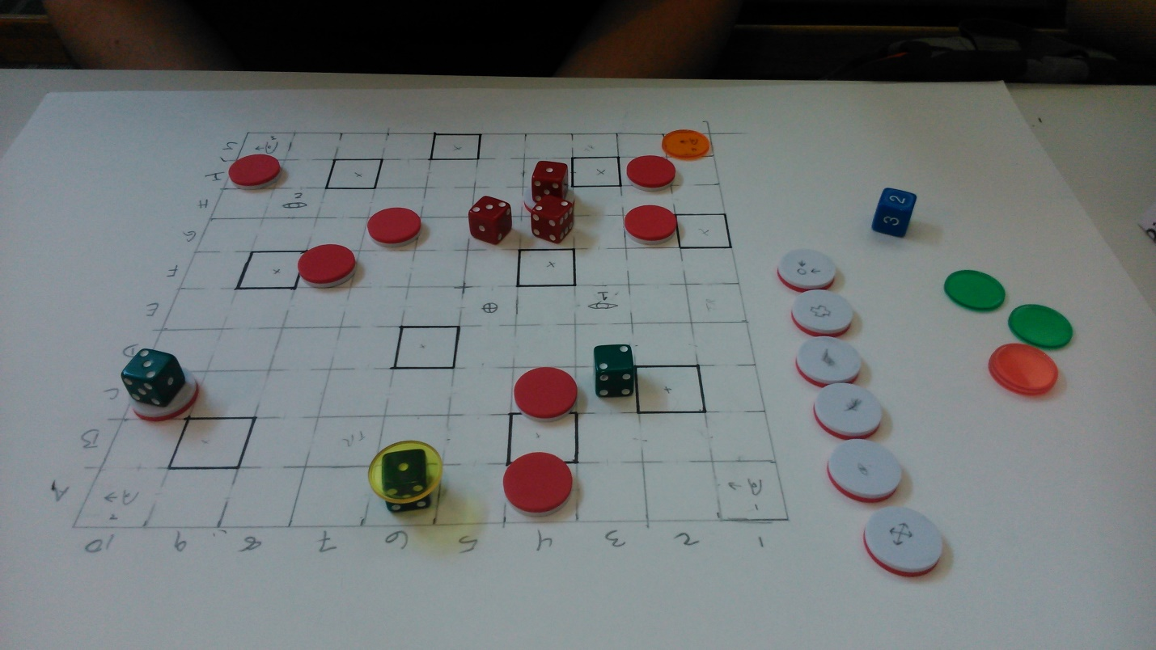

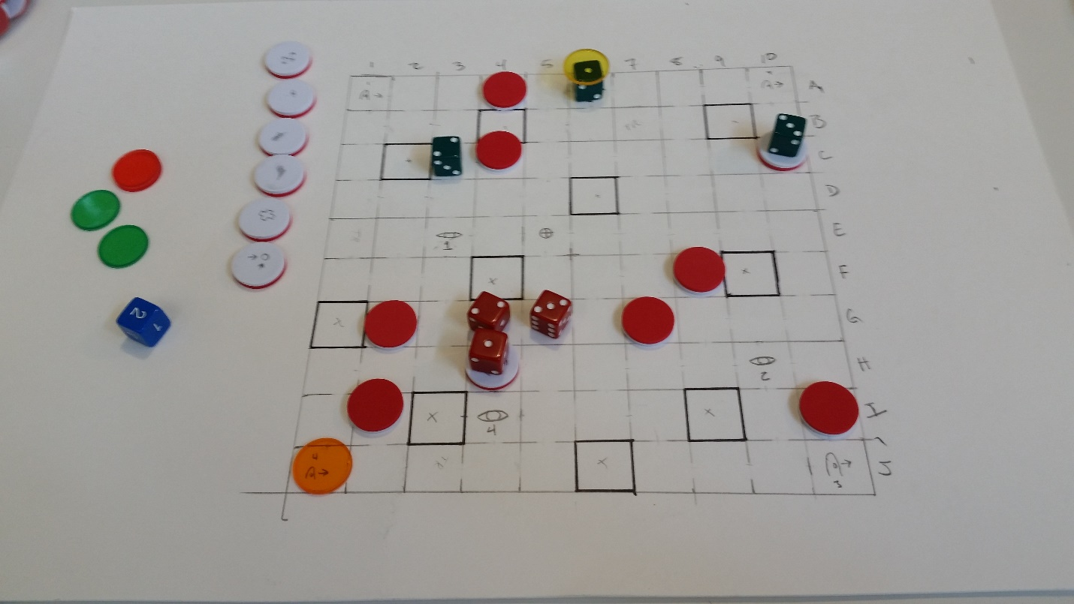Figure 2 Board during secondary playtesting.

Figure 3 Final board layout.

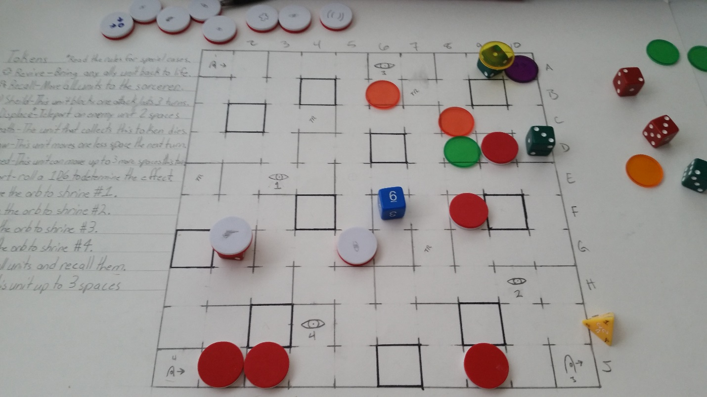

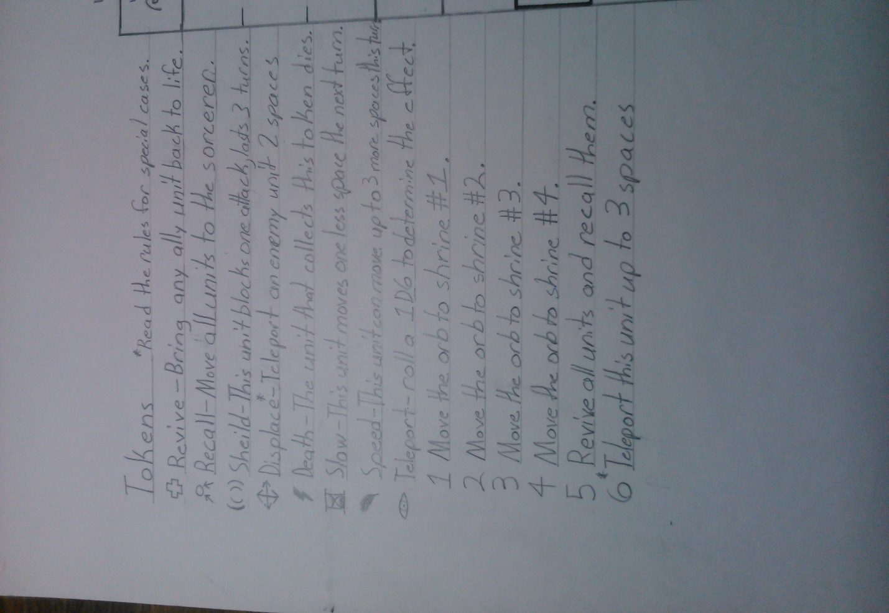Figure 4 Token Reference.